SABA’s Bowhunting Charts (SABA_BC.xlsm)
(This is the documentation for the above spread sheet, used by SABA to chart most variables in relation to bow hunting)
The following sheets are available in the workbook:
- Recommended Penetration – compares a single arrow against all animal categories
- Arrow Selector – compares different arrows for a particular animal
- Arrow Builder
- VMK model
- Speed
- Virtual Mass model
- Poncelet

Recommended Penetration
Please note that the recommended values are based roughly on the averages of successful hunts, and not minimum requirements. For minimum requirements the formulas could be adjusted to accommodate 50% penetration of the animal’s thorax, however we believe following the minimum rather than optimum requirements is not advantageous to bowhunting.
The theory:
This sheet charts the predicted penetration depth of a particular arrow against the various animal categories as defined in SABA’s BProC. It integrates F_{r} = R_{o} + kR_{o}.v², with k=0.001, over distance penetrated, until v²<0.1 m²/s². The value of k was chosen such that predicted penetration is proportional to arrow momentum. An estimation of energy loss for breaking a rib on entry is subtracted before the integration.
It also lists the maximum hunting distances suitable for a particular grouping size, or animal’s reaction time, whatever is the shortest.
As an additional function, it computes the Ro value for a broadhead. This is the penetration resistance of the broadhead at negligible speed. It can be measured directly as the maximum force in pounds needed to push the broadhead through a 1 inch rump streak (mechanicals wit open blades). It is not a very precise measurement, and the formula R² is about 95%.
The relative body width (in inches) is estimated as 3 x body weight^{1/3}. The energy loss (in vt.lbs) to break a rib on entry is estimated as 5 x body weight^{1/3}.
Usage:
All parameters (white squares) can be changed by the user.
Inputs:
Arrow Weight: The total arrow weight in grains.
Arrow Speed: as measured at 1Y in front of bow.
Hunting point - Height: height of blade above the shaft in inches
Hunting point – Length: the length of the cutting edge in inches
You must enter each blade’s dimensions separately.
Shaft diameter: in inches.
Tip Angle: The biggest angle between the flats of chisel points, or twice the angle between the cutting edge and the arrow axis for cut on contact points.
Cutting edge angle: The angle between the two sides of the cutting edge. If single bevelled, the cutting edge angle is the same as the grinded angle, however if double bevelled, it is twice the grinded angle.
Type of tip: chisel or cut-on-contact.
Shaft factor: ferule is thicker/thinner/similar to shaft. It takes the shaft effect into account as reported by Ashby: 60% penetration for shafts thicker then ferrule, 90% for similar, relative to thinner shafts.
FOC: the front of centre of the arrow. Ashby reported penetration doubles as FOC is increased from 15 to 25%. An empirical relationship was used: k =1 + [(36-f)⁹/f⁹ + 1]⁻¹, which returns 1x at 15% and 2x at 22%.
Measured R_{o}: If provided, replaces the calculated R_{o} used in predicting penetration.
Grouping Size – distance: The distance at which a grouping of 6 arrows was shot.
Grouping Size – circumference: The circumference of the smallest polygon that will cover all the shots – with a tape measure wrapped around all the shafts where they enter the arrow stop.
Safety factor: 1 – no margin of error, 2 – allow for double the grouping size.
Outputs:
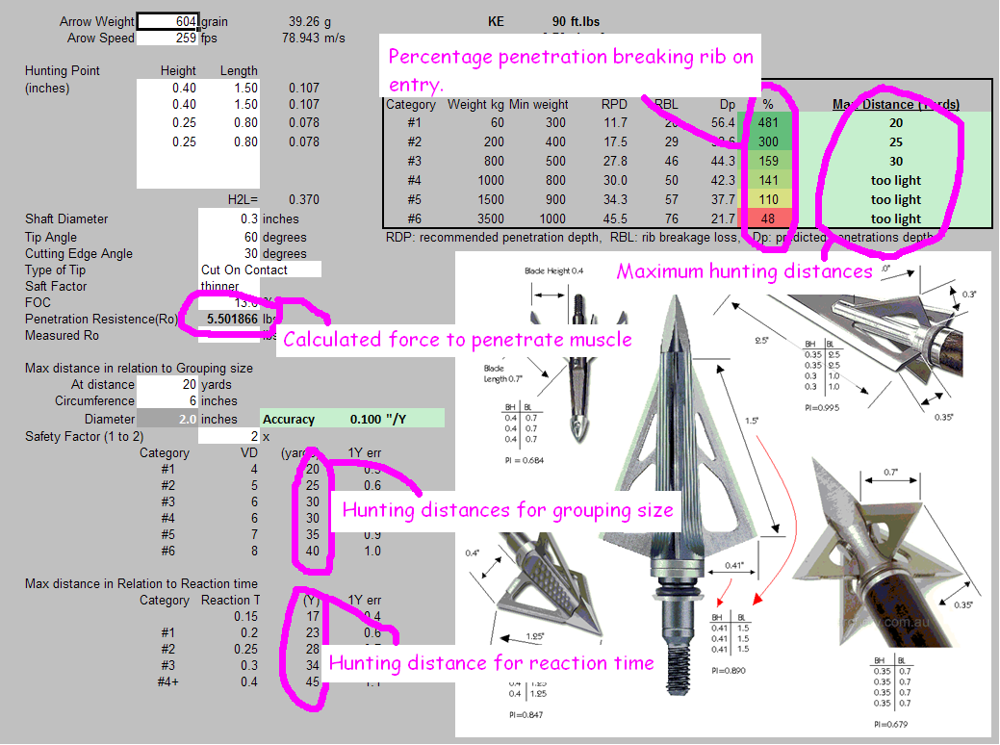
KE: kinetic energy (foot pounds) = m.v²/450,240
mom: momentum – slug feet per second. = m.v/224,000
H²L: sum of blade resistances, can be used as a blade resistance index
Penetration Resistance (R_{o}): calculated force needed to push blade through 1” thick muscle tissue, in pounds.
Accuracy: grouping size in inches per yard. Good values are below 0.1.
Maximum Distances – Yards: as calculated based on grouping size and reaction time.
1Y error: The error in inches in missing the exact aiming point if the target is 1” closer or further than the ranged (aimed with) value.
Percentage Arrow Penetration (PA%) – indicates the suitability of using this arrow to hunt a particular animal in relation to penetration depth. Also bear in mind that as the percentage decrease below 100%, the probability of wounding (and being deflected by a rib) substantially increases.
Maximum hunting distances: recommended max distances to hunt at is the least of the distances based on reaction time and grouping size. Also indicates if the arrow is below the recommended arrow weight.

