Dynamic Spine II by Harry Marx

After the previous article on Dynamic Spine I realized a lot still needed to be said about d-spine. In the previous article two equations were discussed, one providing an indication on the critical buckling force (the biggest constant accelerating force the arrow can withstand without buckling), and the frequency at which the arrow vibrate. This in retrospect was only an introduction... Alas, although this article brings us to a theoretical conclusion, we now need to test this theory to bring us closer to an understanding of d-spine.
Sometimes I see an arrow doing the craziest dances all over the place, just to shoot perfectly straight the next time. Are my arrows too flexible, or too stiff? Paper tuning is perfect, walk back tuning is perfect, and when switching from fieldpoints to broadheads I see no detectable change in the arrow’s grouping or placement. So why do these arrows sometimes do the Mambo?
If you are not at all into maths and engineering physics, and only into shooting, you can skip the rest and directly go to “Results”...
I will first discuss d-spine as it is important to compound bows, and then traditional bows, where frequency is the important component.

I have often asked the question, can arrows be too stiff? And typical hard headed as I am, I wanted to see proof. Finally, I am getting proof…

d-Spine – for compound bows
The deflection of a shaft with a particular length and stiffness, being bent with a force from its side, is described by this equation: D = FL³/48EI. It tells us that the deflection is directly related to a force pushing on the side of the arrow, and related to the length of the shaft multiplied by its self three times. (The 48EI describes the stiffness of the shaft.) It however does not describe how the deflection changes in time, from the moment of release, to the arrow leaving the string, or how it bends if the arrow is pushed from behind instead of the side.
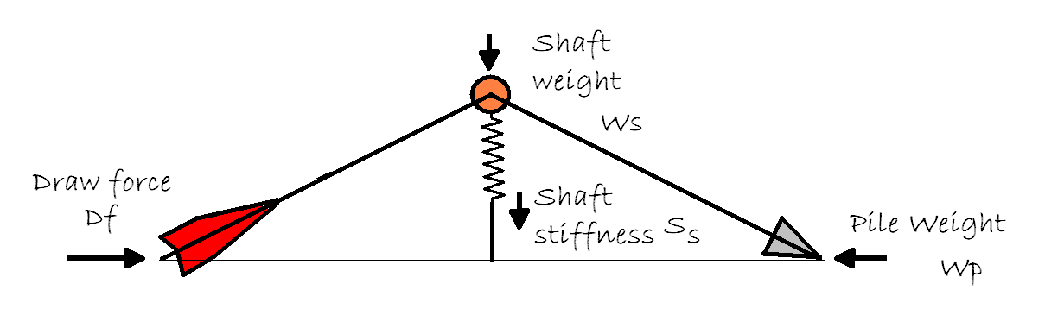
An arrow being shot will bend being compressed between the string pushing it forwards, and its own weight resisting the acceleration. At the same time the weight and stiffness of the shaft resists this bending. This bending happens in a very short time, and you could say that only a part of the force is effective, since the arrow leaves the string too quick for the whole force to apply.
We can employ a model to investigate this. This model contains two rigid weightless levers (two halves of a shaft), connected with hinge, a mass equal to half the shaft weight fixed to this hinge, and a spring that pulls the levers straight to represent its spine or stiffness.
Important to notice is that the arrow bends not according to the bow’s draw weight, but according to the “g-forces” it experiences being accelerated. This force is twice the product of the arrow’s pile weight and acceleration. Also notice that weight behind any point on the arrow’s shaft, cannot add to the weight that bends the part behind it, but instead adds to the weight that resists the bend. Therefore the total weight that bends the arrow is the pile weight plus about half of the shaft weight (Wp + Ws/2). Also the fraction (R) of the force that bends the arrow is proportional to the ratio of the already existing deflection, to half the distance from the nock to the point:
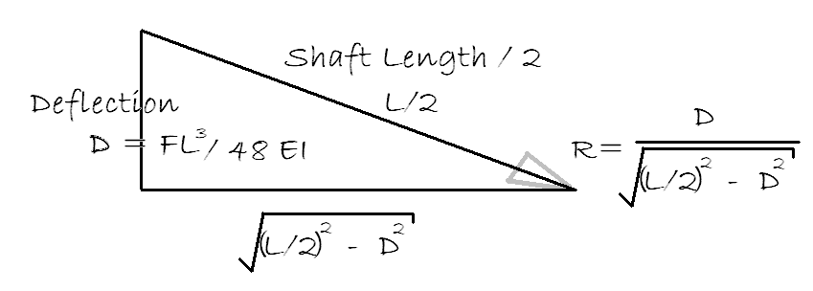
The fraction of the axial force (F_{a}) that is available to bend the arrow is of course zero if the arrow is perfectly straight and infinitely large if the arrow is bent all the way.
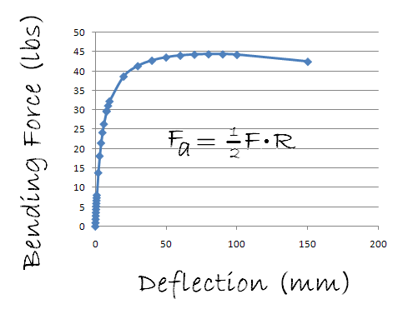
The spine, modelled as a spring, resists this bending force, and this resistance increases with the deflection. If the shaft is perfectly straight then the curve of the axial force needed to bend the arrow starts of at its critical buckling force, and decreases as you bend the arrow. To see if this makes sense, we can draw a curve of the deflection and compare it to the axial force needed to bend the arrow. More realistic, if the arrow is not perfectly straight, or the force is slightly off centre, the axial force curve looks like the one shown here. Calculating the critical buckling force the arrow, in this case, 47.2 lbs (calculated by the approximation done in the previous article), we can see that it closely resembles the curve’s maximum of about 45lbs.
Another interesting feature of this model is the decrease of the resistance against deflection as the arrow is bent beyond a certain point. This resembles the catastrophic failure of an arrow that is pushed too hard - it reaches a point where the arrow needs less force to bend it further than it is currently supporting, and collapses.
The neto-bending force is of course F_{g} – F_{a}, where F_{g} is the g-force experienced during release. The last piece in this puzzle is to apply this force to the weight of the part of the shaft that is being deflected, which is approximately W_{s}/2. You will recall I mentioned earlier that any mass in front of a certain point on the shaft bends it, and the mass behind this spot resist the bend. If you add all the weights before and after all points on the shaft, you will see that the shaft weight adding to the bending force is half of the shaft weight, and the part that resists it is the other half of the shaft weight.
If we take these forces and apply them for a fraction of a millisecond to the model each time, until the arrow escapes the string, we can calculate how far it bends. If anybody wants to play with a computer program implementing this, you can contact me: marxh@unisa.ac.za.

Results
Using a bow and arrow with the following specifics as a basis, each parameter was changed in turn, so that we can see how the model’s prediction on d-spine changes: s-Spine: 300, Draw weight: 70lbs, Arrow rest to within 0.5mm centre shot, Nock travel within 3mm of a straight line, Broadhead 100gr, shaft weight 10gpi, shaft length 30 inches, and Arrow’s straightness < 0.006
The “initial deflection” is again an approximation, to accommodate a number of “imperfections” of real bows and arrows: the nock travel which is not straight, the arrow rest which may not be perfectly positioned and the arrow that is not perfectly straight.
Parameter changed | Range | Deflection (mm)
Draw weight | 50 to 90 lbs | 4.6 to 12.8
Broadhead weight | 65gr to 200gr | 7.1 to 10.6
Spine | 200 to 600 | 3.8 to 15.3
Shaft Weight (gpi) | 6 to 14gpi | 10.4 to 7
Shaft Length | 26” to 32” | 5.2 to 9.7
Arrow Straightness | 0.006 to 0.001 | 8.4 to 8.0
Arrow Rest | 0 to 2 mm out of place | 7.2 to 11.8
Nock travel | 1 to 4 mm deviation | 3.8 to 10.7
The arrow speed was calculated with an adaptation of the virtual mass model that relates stored energy, arrow speed and arrow weight: E_{t} = (m+M+Km³).v²/450240. But more on this equation in another article... for now it suffice to say that it provides for energy losses with extreme heavy arrows.

Conclusion
There are many and varied factors influencing dynamic spine. The model presented here, based on a simple interpretation of Newton’s laws of motion and numerical analysis, predicts the effect of most of these parameters. The prediction of the bending of the shaft during release may not be extremely accurate, however the changes in the bending is fairly consistent with what would be expected from a real arrow.
The bigger influences on d-spine are the straightness of nock travel, arrow rest tuning, draw weight, broadhead weight and s-spine. The smaller influences are made up of shaft straightness, weight and length.
And this brings me to the answer of why arrows seem to do the Mambo sometimes... bow hand torque, bow heeling, pulling or pushing the bow, all moves the nock and rest relative to each other during the release. As you saw the model predicts that this has a major effect on how much the arrow bends when it is released! Therefore, the d-spine is affected by release form!
But this model and equations are not helping us a lot. What we really want to know is what s-spine should I use for my bow, and when I get the nearest available s-spine, to what length should I cut it. Here is an empirical equation based on the model that answers this question:
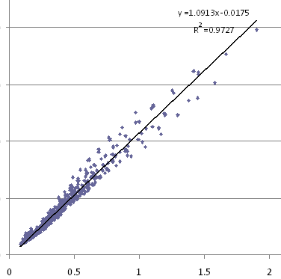(Dw draw weight, DL draw length, Bh brace height, Wp pile weight, L shaft length, Ws shaft weight, S spine)
This graph here is a plot to show you how relevant this equation is. 97% of the model’s predicted deflection is accounted for by it. Further down is a table of a number of set ups. How does it compare to your current set up?
For my own setup (pile weight 215gr, gpi 13, spine 280, 30” draw length, 7.25 brace height, 72 lbs and 29” shafts) it predicts a deflection of 8.5 mm. I have a suspicion that this is a fair deflection for a 600gr arrow at 262fps. I had a look at Easton’s spine charts, and in general they try to keep the deflection of the arrow below 10mm. I would suggest you can start at 10mm, and decrease the s-spine of the shafts you test, to about 5mm. The best value will very much depend on your bow, since nock travel, inherent from the bow’s design, will place a limit on the stiffest arrow that still group nicely.
Current setup |  |  | a maximum of 0.3" deflection is suggested
Current setup | Draw Length | Inch | 24 | 28 | 28 | 30 | 30 | 30
Current setup | Brace Height | inch | 7.25 | 7.25 | 7.25 | 7.25 | 7.25 | 7
Current setup | Pile Weight | grain | 125 | 125 | 125 | 125 | 215 | 180
Current setup | Shaft Weight | gpi | 6 | 9 | 10 | 10 | 13 | 18
Current setup | Draw Weight | lbs | 40 | 60 | 70 | 70 | 72 | 90
Current setup | Shaft Length | inch | 24 | 28 | 28 | 29 | 29 | 30
Current setup | s-spine | inch*1000 | 700 | 400 | 350 | 300 | 280 | 220
Calculated values | total weight | grain | 269 | 377 | 405 | 415 | 592 | 720
Calculated values | d-spine | inch | 0.218 | 0.291 | 0.308 | 0.319 | 0.327 | 0.287
Changes suggested | s-spine | inch*1000 | 981 | 412 | 341 | 283 | 257 | 230
Changes suggested | OR
Changes suggested | Shaft length | inch | xxx | 29.5 | xxx | xxx | xxx | 32.4
Now before we are paralysed by all the maths, wink, wink, we better go and shoot a few arrows!

d-Spine for Traditional bows
In the previous article we discussed how d-spine has two components to it, the amount of deflection, and the frequency of deflection. For traditional archers, or more correct, bows without a “cut-out” riser, where the arrow has to go past the riser and not through it, the frequency is the important one. The equation published previously was simplified and refined somewhat, and we actually have some results on its accuracy now.
Wp is the pile weight of the arrow, L the shaft length, S the s-spine, and Ws the shaft’s weight per inch (as GPI).
I have used this equation to predict the frequency of a number of different arrows, and compared this to measurements as made by Bertil Olsson. I was astonished at the accuracy of the results. The total weight of the arrows he tested varied from 291 to 500 grains, the s-spine from 700 to 390, the length from 32.3 to 27.4”, and pile weights from 89 to 180gr. The largest error was on the arrow with the smallest shaft weight (5.9gpi), and it was a mere 3.1 Hz more than the measured value of 87.6Hz. The equation describes 98.7% of the measured values – as theories go, this is GOOD.
Arrow | W_{t} | L | W_{p} | W_{s} | S | F_{m} | Fp | Error
Wood HPD | 500 | 32.3 | 126 | 10.9 | 550 | 50.4 | 49.6 | -0.8
X7 1914 | 375 | 28.8 | 100 | 8.9 | 660 | 65.9 | 64.1 | -1.8
XX75 2213 | 440 | 30.6 | 129 | 9.5 | 460 | 67 | 65.2 | -1.8
X72314 | 525 | 30 | 180 | 10.8 | 390 | 68.9 | 69.3 | 0.4
Cartel Tri 700 | 291 | 29 | 92 | 6.1 | 700 | 75.8 | 74 | -1.8
ACE 520 | 292 | 30.3 | 89 | 6.0 | 520 | 79.7 | 78.8 | -0.9
ACC 560 | 325 | 27.4 | 103 | 7.3 | 560 | 83.5 | 85.5 | 2.0
ACE 520 | 308 | 28.5 | 120 | 5.9 | 520 | 87.6 | 90.7 | 3.1
Wt – total arrow weight, L arrow length, Wp pile weight, Ws, shaft weight, Fm measured frequency, Fp – predicted frequency
The next question you will ask now is what frequency is the correct frequency for your bow. Stu Miller has developed and excellent spine calculator for non-compound bows. It has a collection of a huge number of commercial shafts, and he actively keeps this up. You will find it easily with Google. I used this calculator of his to compare results of my model with his empiric formula (empiric: based on describing the relationship and not explaining it). (Just a short reminder: The frequency will determine how fast the arrow vibrates or bend, and therefore how much time it will take to move the fletches out of the way of the riser as it passes to the side of it.)
The draw-force curve for a typical non-compound bow can be approximated to a straight line, increasing from 0# at brace height, to let’s say 70# at 29”. This would imply that the average acceleration of the arrow will be half the maximum draw force at full draw divided with the total arrow weight. The draw-force curve for these bow designs is usually slightly higher than a straight line, but then we also ignore the string weight and limbs weight, so we hope things equal out. The approximation would suffice for getting a ball park figure.
For our bow, with a brace height of 8”, which imply a power stroke of 29-8, 21”, and 70/2#, you can expect a 434gr arrow’s fletches to take about 16.3 milliseconds to reach the point where it should start to move the fletches away from the riser.
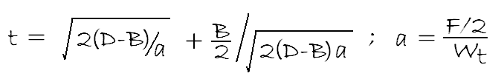
D is drawlength, B braceheight, F draw weight, and W_{t} is the total arrow weight.
Now 16.3 milliseconds correspond to 61.2Hz (F=1/t). According to Stu Millers’s calculator, the following arrow would have been perfect: Shaft size: 2213, 29” with a 125gr broad head. If we calculate the frequency for this arrow, it comes to 64.4Hz. I am inclined to believe Stu Miller’s calculator is correct. The difference between 64.4 and 61.2 Hz (3.2Hz) corresponds to about 0.5” of shaft length. To equalize the frequency exactly, the arrow will need to be 30” long. This difference in frequency represents about 6cm of travel. But here is a table of a view different arrows:
 | Wp | Ws | S | DL | Bh | DF | L | Wt | fps | millis | Fn(arrow) | Fn(bow) | Error (Hz)
xx75 2213 | 150 | 9.5 | 460 | 30 | 8 | 50 | 31.5 | 449 | 194 | 19.8 | 54.2 | 50.6 | 3.7
 | 125 | 9.5 | 460 | 30 | 8 | 60 | 30.65 | 416 | 219 | 17.5 | 57.7 | 57.1 | 0.5
 | 100 | 9.5 | 460 | 30 | 8 | 70 | 30.13 | 386 | 244 | 15.7 | 60.3 | 63.6 | -3.3
1914 | 150 | 8.9 | 660 | 27 | 8 | 46 | 29.3 | 411 | 179 | 18.6 | 54.1 | 53.8 | 0.3
 | 150 | 8.6 | 660 | 27 | 8 | 56 | 27.8 | 389 | 202 | 16.5 | 61.1 | 60.6 | 0.5
 | 125 | 8.6 | 660 | 27 | 8 | 65 | 27.4 | 361 | 224 | 14.9 | 63.3 | 67.3 | -4.0
These arrows are matched to the bows using Stu Miller’s calculator. As you can see the frequencies we predict is slightly different. In the next table, I have matched the arrows to the bows using the frequency. You may notice that according to this prediction, the last arrow may be slightly too short.
 | Wp | Ws | S | DL | Bh | DF | L | Wt | fps | millis | Fn
xx75 2213 | 150 | 9.5 | 460 | 30 | 8 | 50 | 32.8 | 462 | 192 | 20.0 | 50.0
 | 125 | 9.5 | 460 | 30 | 8 | 60 | 30.8 | 418 | 219 | 17.5 | 57.1
 | 100 | 9.5 | 460 | 30 | 8 | 70 | 29.2 | 377 | 246 | 15.6 | 64.2
1914 | 150 | 8.9 | 660 | 27 | 8 | 46 | 29.4 | 412 | 179 | 18.6 | 53.7
 | 150 | 8.6 | 660 | 27 | 8 | 56 | 27.91 | 390 | 202 | 16.5 | 60.6
 | 125 | 8.6 | 660 | 27 | 8 | 65 | 26.46 | 353 | 226 | 14.7 | 67.9
The final question is again, which one works for you? Please let me know. If you match the frequency of the accelerating arrow with the bow’s required frequency, you could be fine. Or you could simply use Stu Miller’s calculator. Or like millions of archers did for many years in ancient times, you can simply shoot hundreds of different arrows and keep the ones that work. I guess it would be lots more fun anyway. However if you are inclined to understand why it works like it does, I think we have provided some valuable food for thought.
And finally, a last word on d-spine: it is important, but without practice, it’s just boring maths…

